EXP 4: Create a simple cloud software application for Car Booking Reservation System using any Cloud Service Provider to demonstrate SaaS.
DATE:28-02-26
AIM: The aim of the Car Booking Reservation System SaaS is to provide a scalable, user-friendly platform for customers to book rental cars online while enabling businesses to efficiently manage reservations and car fleet availability.
PROCEDURE:
STEP1:GO TO ZOHOCREATOR.COM AND LOGIN TO YOUR ACCOUNT
STEP2:CLICK CREATE NEW APPLICATION AND CREATE FROM SCRATCH
STEP3: ENTER APPLICATION NAME AND CREATE APPLICATION
STEP4:CLICK ON CREATE NEW FORM AND NAME THE FORM
STEP5:ENTER THE DETAILS
STEP6:THE SOFTWARE HAS BEEN CREATED.

STEP1:GO TO ZOHOCREATOR.COM AND LOGIN TO YOUR ACCOUNT

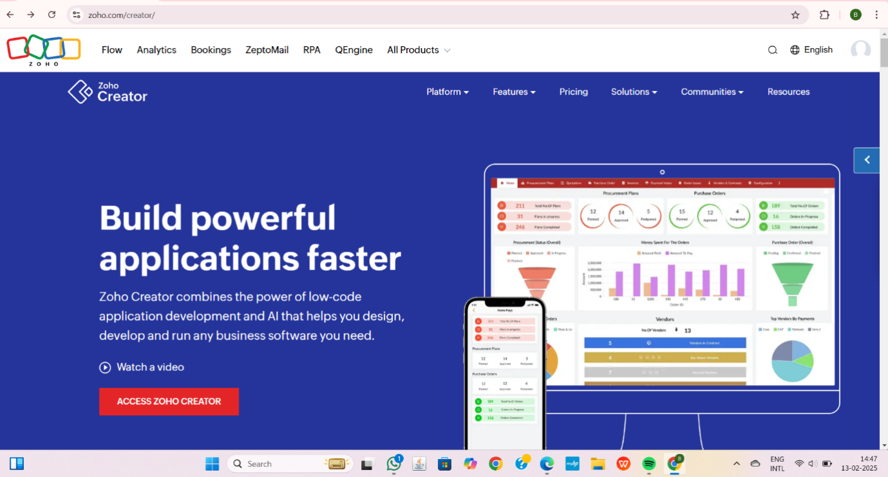

STEP2:CLICK CREATE NEW APPLICATION AND CREATE FROM SCRATCH
STEP3: ENTER APPLICATION NAME AND CREATE APPLICATION

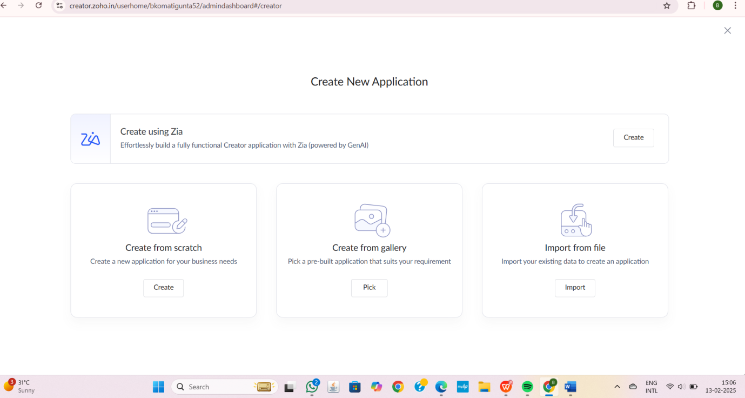

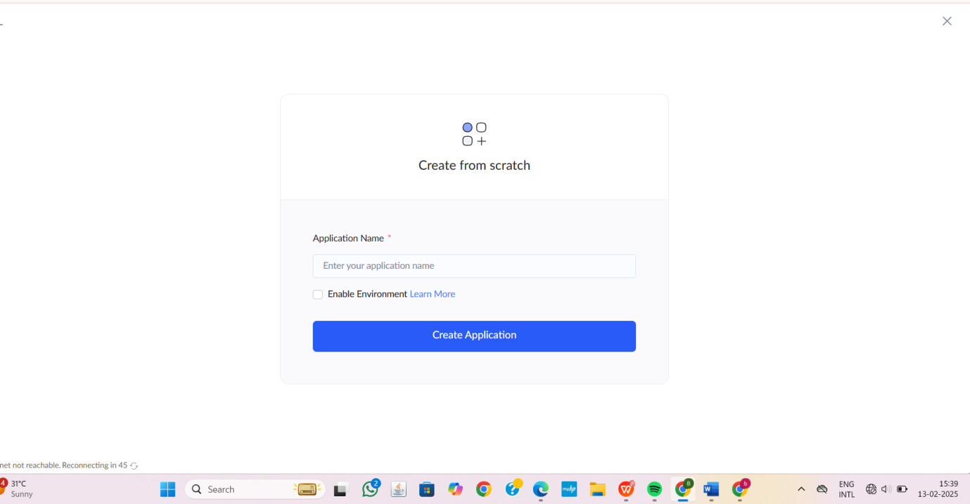

STEP4:CLICK ON CREATE NEW FORM AND NAME THE FORM

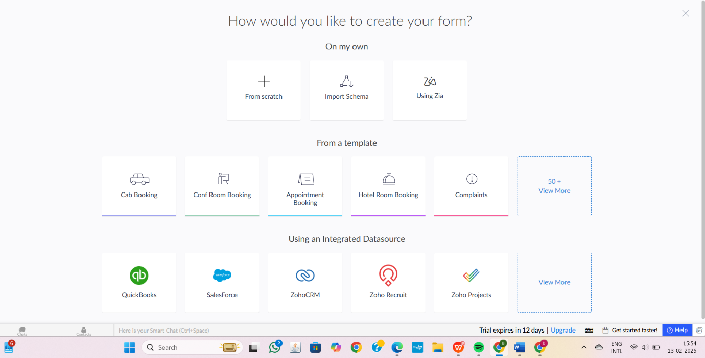

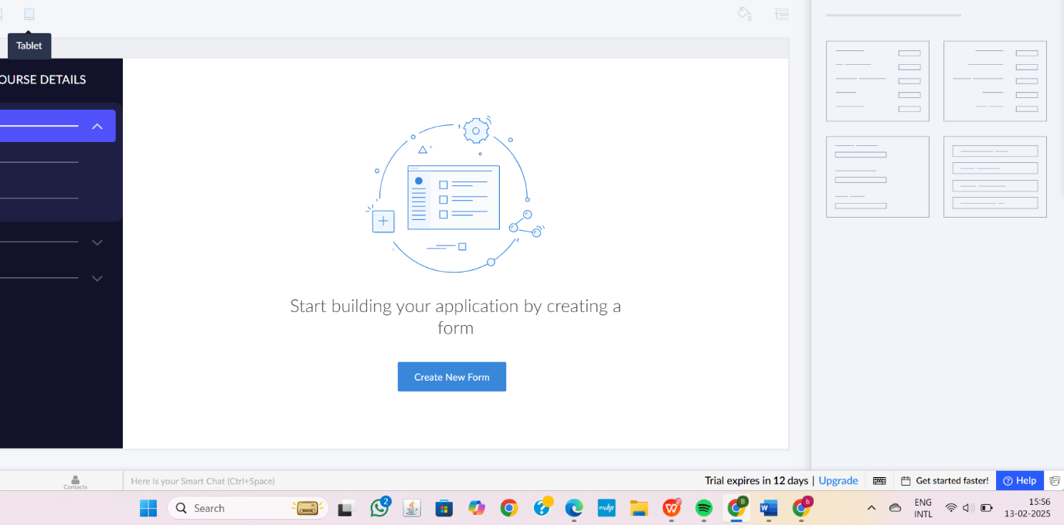

1.CUSTOMER INFORMATION AND ITS DETAILS
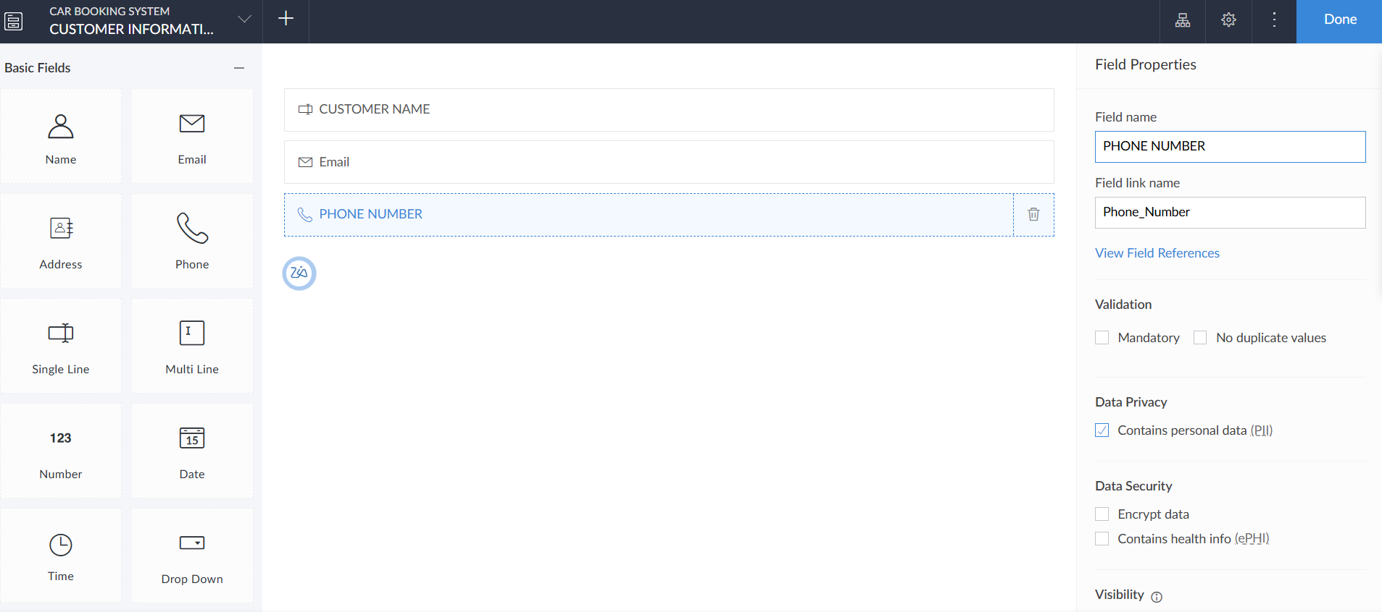

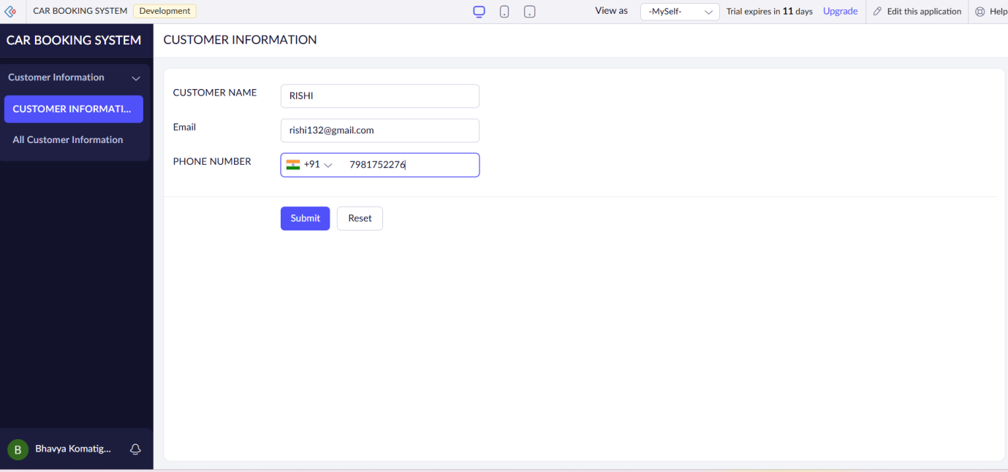

2.BOOKING DETAILS
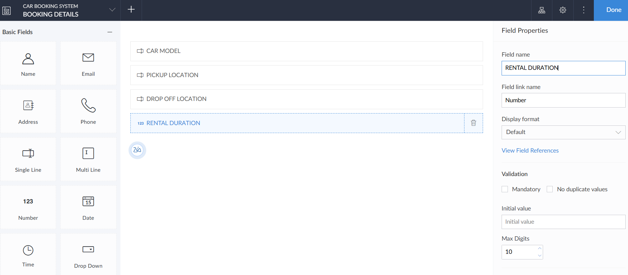

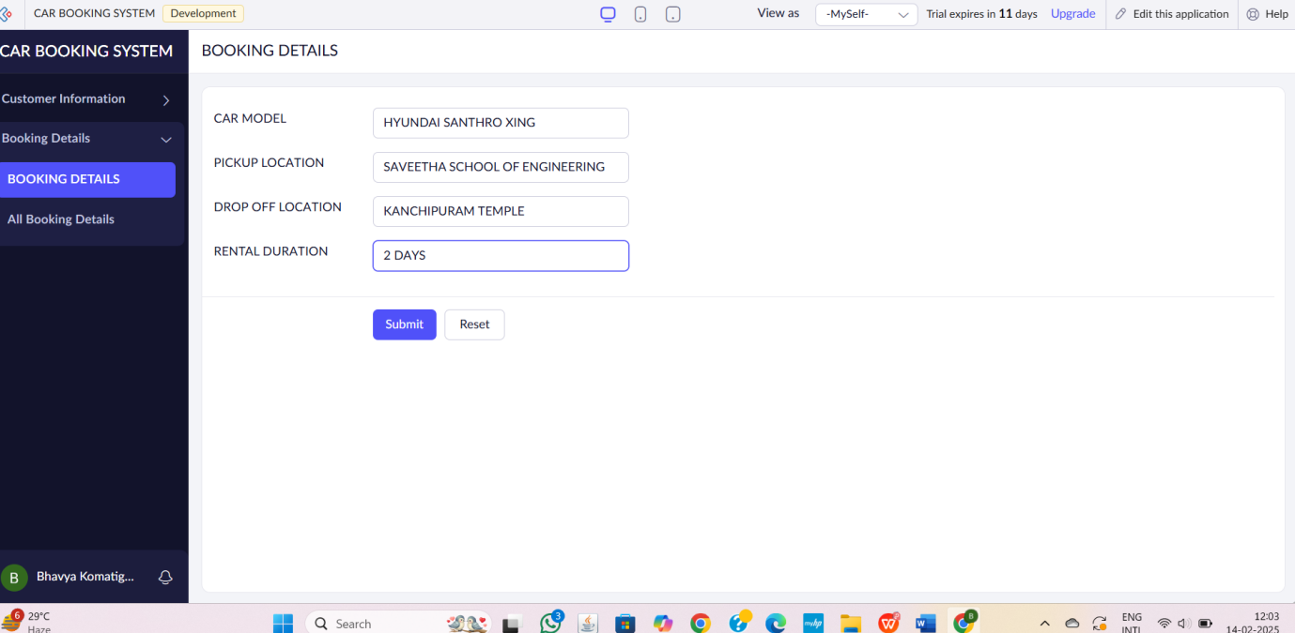
3.PAYMENT INFORMATION
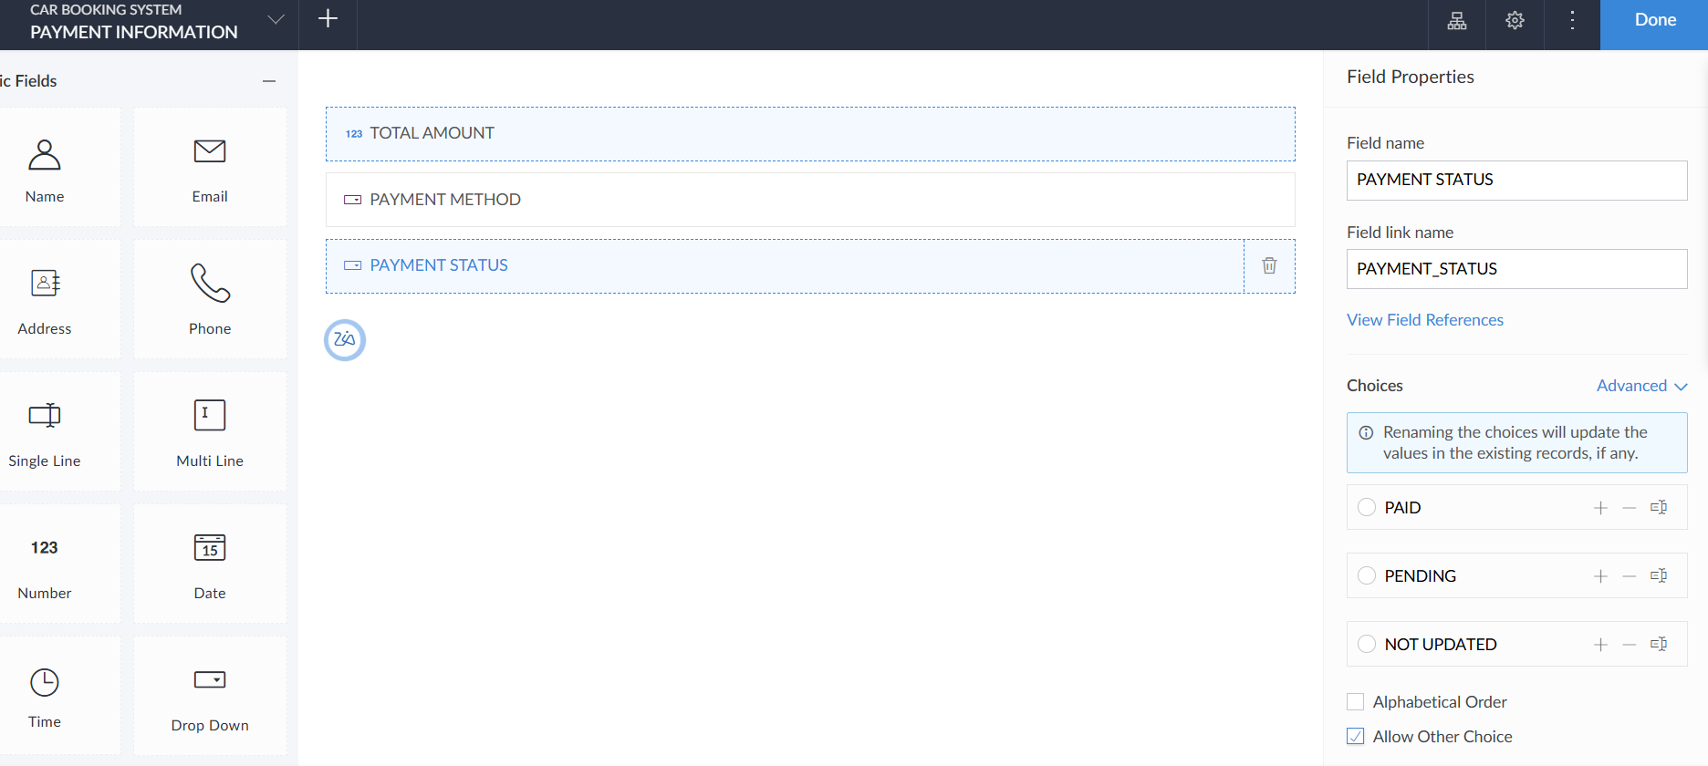

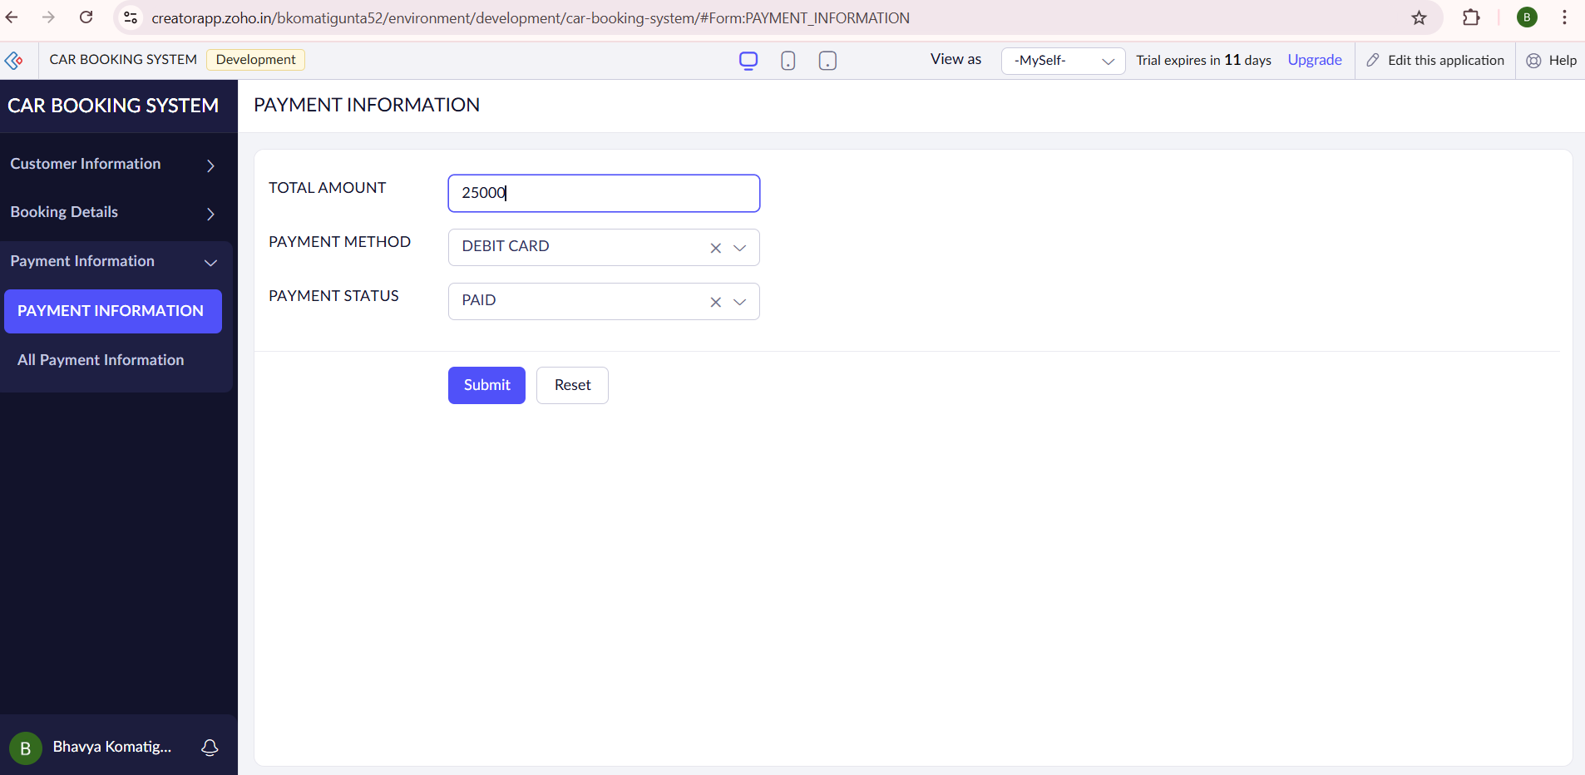

STEP6:THE SOFTWARE HAS BEEN CREATED.
